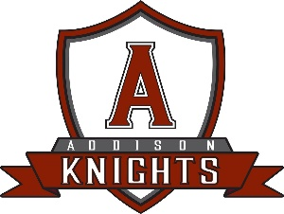
Addison Central School District
Transportation Department
14 Cleveland Drive
Addison, NY 14801
leldridge@addisoncsd.org
607-359-2415

NON-PUBLIC TRANSPORTATION REQUEST FORM

Please complete the information below if your child will be requiring ACSD transportation to a non-public school during the 2025/2026 school year. Please return this completed form via mail or e-mail to the attention of the Transportation Department. All forms must be received no later than April 1st to have transportation available the first day of school.

Non-Public School Name: ____________________________________________________
Student Name: ___________________________________________ Grade: ___________
Parent/Legal Guardian Name: ____________________________________________
Address: __________________________________________________________________
_________________________________________________________________________
Daytime Phone (1): ___________________ Daytime Phone (2): ______________________
Requested Transportation:
AM Only PM Only Both (AM/PM)

Office Use Only

Bus/Van #: __________
Estimated Pick Up Time: ___________ Estimated Drop Off Time: ______________

